Prismatic Solar Skin
White Paper Proof of Concept for a Hybrid Solar, Thermal-Recovery, and CPSS Conditioning Surface
Document Type | Hybrid energy-surface proof-of-concept white paper
Concept Thesis | Combine direct solar collection, thermal/TPV recovery, CPSS conditioning, and prismatic routing into a layered spacecraft energy skin.
Primary Use | Improved total energy yield, thermal recovery, storage conditioning, and managed shipboard power routing
Status | High-level concept architecture draft
Abstract
Prismatic Solar Skin is a spacecraft energy-surface concept that treats solar collection as a layered systems problem rather than a single photovoltaic panel problem. In this architecture, an outer solar collector surface captures direct light, an internal thermophotovoltaic or thermal-recovery layer converts part of the infrared and waste heat that would otherwise be lost, a CPSS-derived conditioning layer buffers and redistributes irregular generation, and a prismatic routing manifold directs the resulting power to ship systems or relay paths. The result is not a claim that one exotic component replaces solar cells. It is a higher-level claim that a better energy skin can be built by combining collection, recovery, conditioning, and routing as one integrated surface.
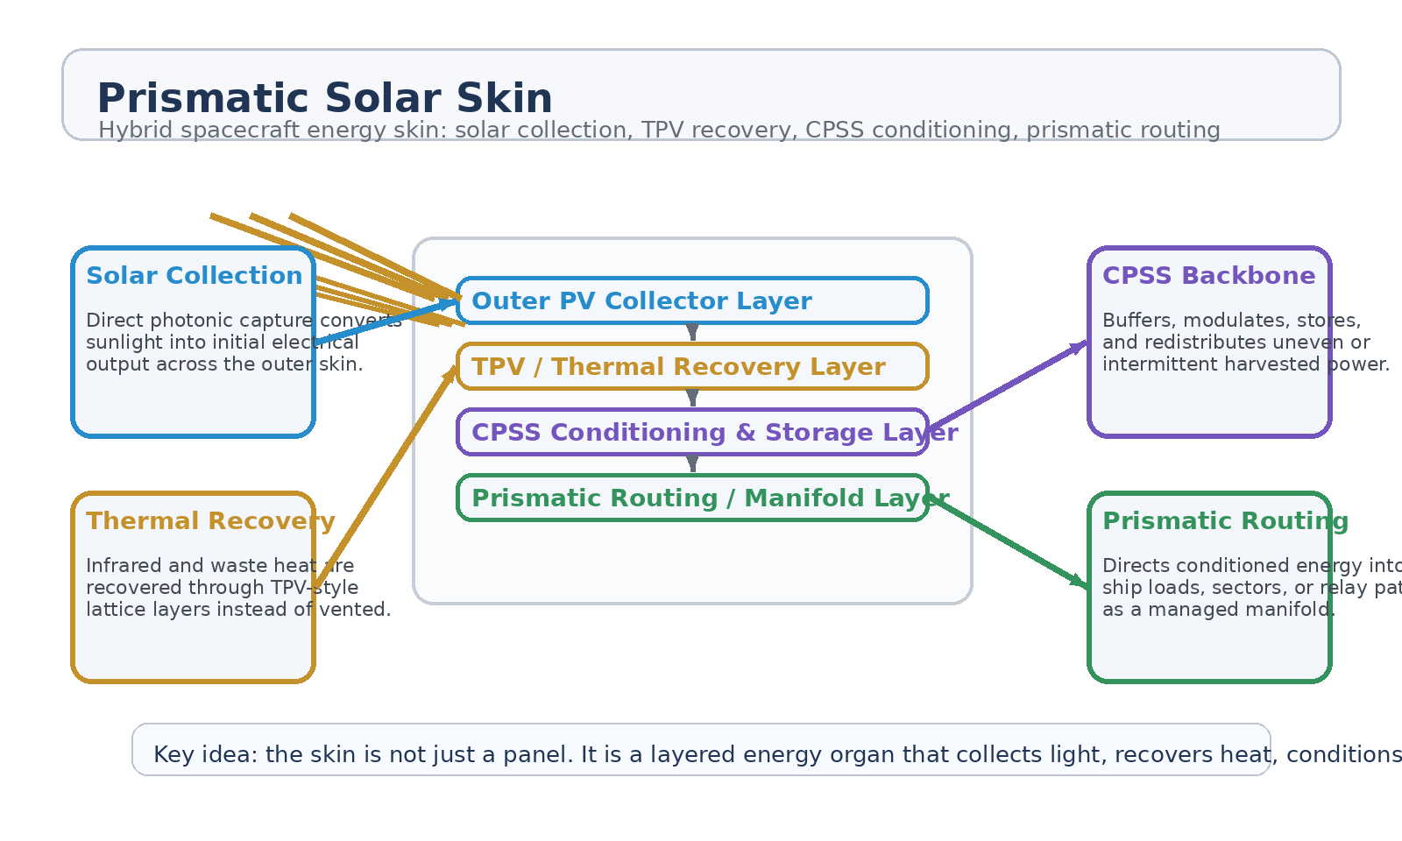
Figure 1. Prismatic Solar Skin architecture with direct solar collection, TPV thermal recovery, CPSS conditioning, and prismatic routing.
1. Concept Thesis
The core idea is that better solar performance on a spacecraft does not come only from asking the photovoltaic layer to do more. It comes from designing the whole surface as an energy organ. Light is collected at the outer face, heat is recovered rather than simply tolerated, power is conditioned close to where it is generated, and routing is treated as part of the skin rather than as an afterthought behind it.
This shifts the architecture from “flat panel plus wires” to “layered skin plus manifold.”
2. Layered Architecture
Layer | Subsystem | Primary Function | Role in Yield
L1 | Outer PV Collector | Captures direct solar flux and performs primary photonic conversion. | Baseline electrical harvest
L2 | TPV / Thermal Layer | Recovers infrared and waste heat that would otherwise be lost. | Raises total recoverable energy
L3 | CPSS Conditioning Layer | Buffers, stores, smooths, and modulates variable incoming power. | Reduces mismatch and transient loss
L4 | Prismatic Routing Manifold | Directs conditioned power to ship systems, sectors, or external relay paths. | Improves usable system output
L5 | Ship Load Interface | Distributes energy into propulsion, shielding, habitation, or storage systems. | Turns harvest into mission value

2.1 Direct Solar Collection
The outer layer remains a true solar collector. This is important. Prismatic Solar Skin does not replace photovoltaic conversion with an exotic field claim. The direct collector still performs the primary job of turning incident light into electrical output.
2.2 Thermal Recovery Layer
Conventional panels shed a great deal of useful energy as heat. In this architecture, a TPV-style or thermal recovery layer is placed beneath the direct collector so infrared spilloff and thermal build-up can be partially converted into additional usable power rather than being treated only as waste.
2.3 CPSS as the Conditioning Backbone
CPSS is best used here not as the sunlight absorber but as the intelligent conditioning layer. Its conceptual role is to accept fast or uneven incoming energy, buffer it, smooth transients, redistribute local surpluses, and maintain a more stable output to the ship. That means the skin can behave more like a distributed energy organ than a brittle panel array.
2.4 Prismatic Routing
The prismatic layer should be treated as the routing manifold behind the skin. Its role is to distribute conditioned output into the vessel with more discipline than a simple static wiring bundle. In a large platform, this means sectors, loads, or auxiliary nodes can be fed from a managed surface rather than one hardwired branch path.
3. Why CPSS Improves Effective Efficiency
The strongest efficiency claim here is system-level, not pure semiconductor-level. CPSS does not make photons magically absorb better inside the outer collector. It improves the amount of harvested energy that remains usable after collection by reducing mismatch, absorbing surges, smoothing intermittency, and supporting local redistribution.
• Accepts fast-changing solar input without forcing abrupt downstream load swings.
• Reduces waste from shadowing, angle changes, or uneven illumination across the surface.
• Supports local buffering so transient surplus is less likely to be thrown away.
• Improves the practical energy yield of the whole skin, even if the PV layer itself is unchanged.
4. Mission Roles
• Primary exterior power skin for long-duration spacecraft or orbital stations.
• Supplemental energy surface on large hull sections where thermal build-up is already unavoidable.
• Hybrid solar-thermal layer for habitats, logistics ships, or relay platforms.
• Distributed power intake for ships that benefit from local buffering and modular energy routing.
• Sectorized energy collection in which damaged or shadowed sections do not collapse the whole array.
5. Advantages Over a Conventional Panel-Only Architecture
• Treats heat as a recoverable resource instead of a pure penalty.
• Moves storage and conditioning closer to the collection surface.
• Allows prismatic routing and sector balancing across the hull.
• Raises overall usable yield through better buffering and reduced transient loss.
• Creates a more resilient energy surface for large spacecraft and orbital infrastructure.
6. Boundaries and Realism
Prismatic Solar Skin is strongest as a hybrid energy-surface concept, not as a claim that one exotic module replaces photovoltaic physics. The outer collector still needs a real solar-conversion layer. The TPV layer still needs real heat to recover. CPSS still works best as a conditioning and storage architecture. The prismatic manifold still routes rather than magically creates power.
• Most credible as a hybrid PV + thermal recovery + conditioning + routing stack.
• Not a replacement for real solar conversion materials.
• System-efficiency gains are more plausible than miraculous collector-efficiency jumps.
• Best suited to larger platforms where thermal management and distributed routing already matter.
7. Proof-of-Concept Build Path
Phase | Goal | Bench / Program Activity | Success Signal
P1 | Hybrid skin baseline | Build a layered mock surface with direct collector plus thermal sensing. | Reliable photonic baseline
P2 | Thermal recovery add-on | Integrate a TPV-style recovery layer or thermal conversion surrogate. | Measured extra recovered output
P3 | CPSS conditioning | Feed the surface into a CPSS-like buffer and compare transient behavior against a direct line. | Improved smoothing and usable output
P4 | Prismatic routing | Route conditioned energy to multiple load zones with a managed manifold model. | Cleaner distribution behavior
P5 | System-level comparison | Compare panel-only and layered-skin architectures under uneven illumination and heat load. | Clear practical yield advantage

8. Conclusion
Prismatic Solar Skin is a stronger concept than a simple “better solar panel” claim because it spreads the problem across the whole energy chain. The outer layer collects light. The inner layer recovers heat. CPSS makes the harvested energy more usable. The prismatic manifold routes that energy where the vessel actually needs it.
As a white paper PoC, it is best understood as a hybrid spacecraft energy skin: not a single miracle material, but a disciplined stack that turns collection, recovery, conditioning, and routing into one integrated surface.
Working one-line doctrine: Do not ask the panel alone to do everything; let the skin collect light, remember heat, condition power, and route energy as one living surface.

